Dominic Ross
OSS Summer 2022
OSS FFRDC Maturity Evaluation

This is a student project created for Carnegie Mellon University - Integrated Innovation Institute - Open Source Software to evaluate the maturity of open source software governance practices at Federally Funded Research and Development Centers.

The Name of the FFRDCs researched will remain unnamed. I do not officially represent an FFRDC about open source, this is a student report and should not be associated with any FFRDC.

Purpose:
Federally Funded Research and Development Centers (FFRDC) are private sector organizations tasked with assisting the U.S. government with long-term research and development. As research matures FFRDCs must open-source software to accelerate the commercialization of technology. Transferring the technology to the public is intended to promote national economic growth while increasing technology development which the U.S. government intends to leverage.

Problem:
Some FFRDC Software Developers are provided limited guidance on how to successfully transition software and actively contribute with the OSS community. The FFRDC GitHub repositories vary in standardization and documentation, with some not explaining what is the software's primary purpose. Documentation and educational resources can be hard to find for FFRDC employees as most information available is from a traditional enterprise perspective. How do you release an open-source project? What licensing options do FFRDCs prefer? Will I have to source an alternate code because I have the wrong license? Will my sponsor believe the OSS software is inferior? Do other FFRDC employees feel equally confused?

Solution:
Create collection resources and data points to promote productive conversations designed to prepare FFRDC employees and their organizations. Survey FFRDC employees to evaluate FFRDC OSS Maturity. Interview FFRDC employees to better understand their relationship with OSS. Clear up any OSS misinformation that might hinder greater community collaboration and software adoption.

Literature Review:
I started my literature review by evaluating my own organization's open source standards and guidelines. I accomplished this through an internal website, wiki, FAQ pages, and preliminary discussions with staff who had some connection to the open source community. I quickly realized that I would be unable to focus directly on my organization without possibly disclosing proprietary information and decided to broaden the topic to be inclusive of federally funded research and development centers (FFRDCs).
On the advice of Professor Wasserman, I expanded my investigation to include guides and resources made available by the TODO Group. I first visited The Evolution of the OSPO Study, a case study collaboration between the TODO Group and Linux Foundation. The case study outlines the TODO GROUP for stages of OPSO maturity and what contribution is expected at each level. A checklist is also present for quick reference.

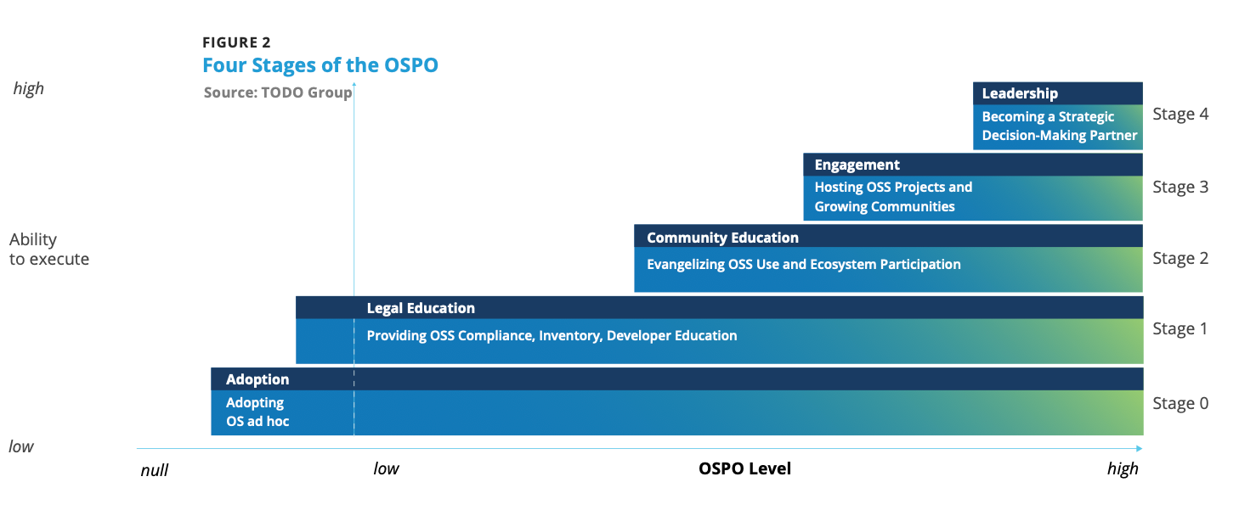
Figure 1: Four Stages of the OSPO - Chris Aniszczyk, Chief Technology Officer, Linux Foundation, Co-Founder, TODO Group With a foreword by Jim Zemlin, Executive Director, The Linux Foundation

New to the idea of an Open Source Project office I decided to search if any of the 42 FFRDCs had an OSPO and was unable to locate definitive proof of existence, although I speculate University FFRDCs may share OPSO++ through the parent University. An OSPO++ "is a network and community of collaboration open source program offices in universities, government, and civic institutions". John Hopkins was the first University to open an OSPO in the United States. On June 26, 2022, Carnegie Mellon announced that the Sloan Foundation will fund a new office to support Open Source Activities, including an OSPO++ which will include guidance for its own FFRDC The Software Engineering Institute.
I found it initially difficult to apply the TODO Maturity Model to FFRDCs, its ambiguity was not an ideal fit for organizations with rigid structures heavily controlled by sponsor guidelines. While applying the checklist many FFRDCs could make the argument that they are level 3, but after reading the study I surmise that is not the intent.
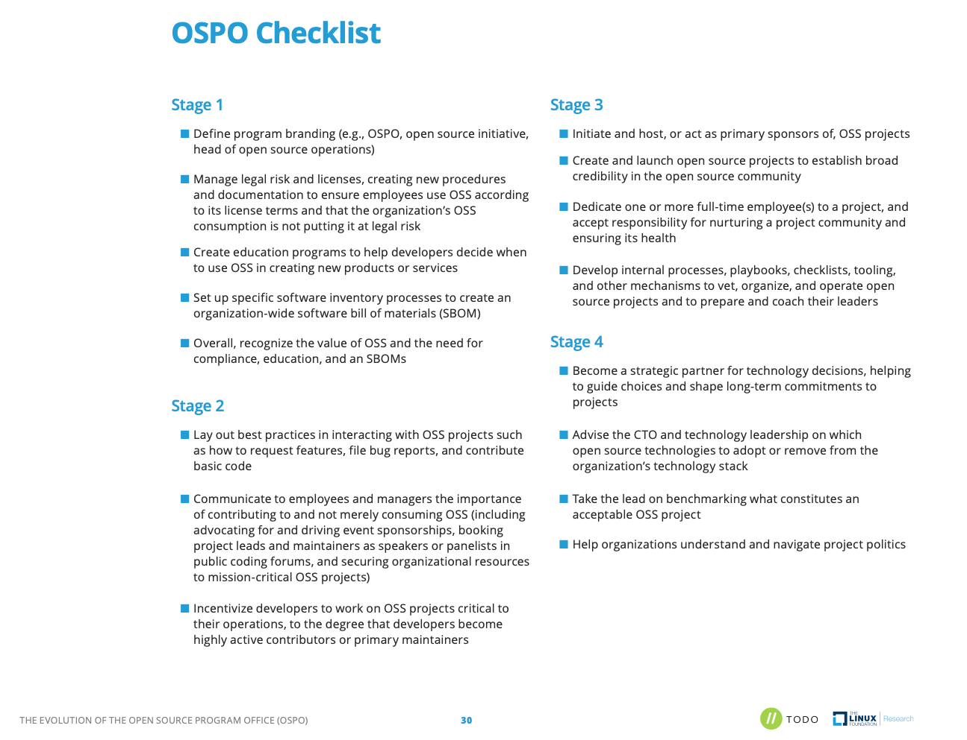

Figure 2: OSPO Checklist Chris Aniszczyk, Chief Technology Officer, Linux Foundation, Co-Founder, TODO Group With a foreword by Jim Zemlin, Executive Director, The Linux Foundation
#I went searching for an additional model with further granularity and found the WIPRO Open Source Maturity Model.
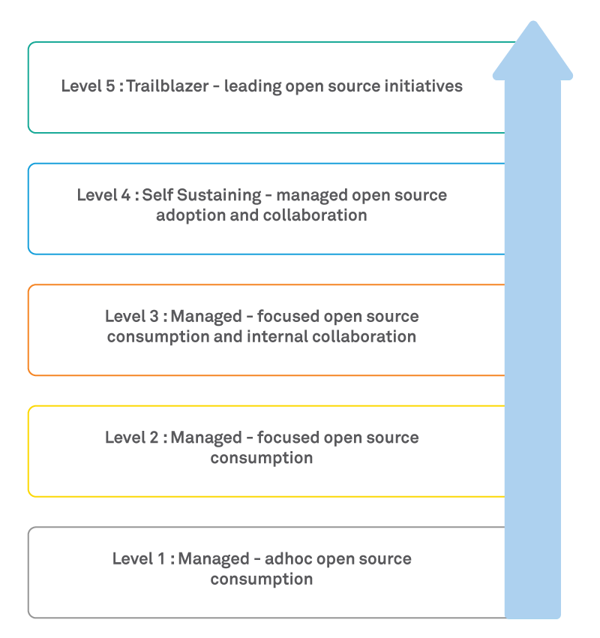

Figure 3: Wipro's Open Source Maturity Model for Enterprises

The TODO and Wipro models are very similar, but I felt the clearer language of the Wipro was easier to align to FFRDCs. The TODO Group also provides an extensive list of best practices. TODO site contains 13 best practices, I have hand selected the practices that tie back to an FFRDC, and I would encourage you to consult them all:
- Using Open Source Code – Detailing the responsible use of an open source. Why you should track and review code. Compliance roles and responsibilities. Establishing a policy for using open source code. A process for reviewing code and version control.
- Participating in Open Source Communities – This is difficult in an FFRDC, and I would highly recommend checking with your organization for its policies and procedures to ensure you remain compliant with any sponsor guidelines. This section details how to contribute to an organization from an enterprise perspective and how to be a good citizen in an OSS community.
- Recruiting Open Source Developers – The limitations of how an FFRDC may contribute to Open Source without violating sponsor agreements may discourage recruiting, but this guide is worthwhile investigating. Many organizations are interested in diversifying staff, as an FFRDC transitioning nonrestricted research to the public is part of the mission. So it makes sense to learn when to recruit and when to train, and how to retain open source developers.
- Starting an Open Source Project – As an FFRDC I would recommend that you first check with your organization before implementing any recommendations to ensure sponsor alignment. This guide goes into the why, when, and where of creating an open source project from an enterprise perspective. Planning the project, creating a business case, allocating resources, quality assurance, launching a project, and legal review and licensing. Again I would highly suggest using this document as research to have a productive conversation with your organization's OSS stakeholders.
- Shutting Down an Open Source Project – Working at an FFRDC you will inevitably have to sunset software. Sometimes a period of funding performance ends, while other times the sponsor decides the work is mature and should be transitioned to the public. Planning an OSS lifecycle is important to set internal and community expectations, while protecting your organization's reputation.
- Building Leadership in an Open Source Community – This guide covers tips for being a good leader in open source communities. As an FFRDC the technology you create is intended to allow the public to quickly transition the product. Being a leader is being a good OSS citizen, employing governance policies, creating an open culture, and promoting sourcing. Roles are also included in this guide but I would suggest checking with your organization before implementing anything from this guide.
- Marketing Open Source Projects – This is another guide I would suggest using as a study aid to promote a positive conversation in your organization to ensure Sponsor compliance. This guide goes into promoting an OSS project to attract contributors and raise project exposure.

TODO Group covers open source mainly from an enterprise perspective so I decided to look to see if the Department of Defense (DoD) had any information related to the consumption and creation of open source and was extremely surprised at the information I found. For the majority of my career, I believed in a rumor that the DoD had little interest in open source and actively discouraged it. I know that now that rumor is malicious misinformation. The U.S. Department of Defense Chief Information Officer maintains the DoD Open Source Software FAQ. The page is designed to educate government employees and contractors on the policies and legal issues regarding open source software. This is one of the most mind-blowing resources I have ever encountered as an FFRDC employee. The wealth of knowledge included in this FAQ provides a roadmap for how any government employee or contractor can leverage OSS. I will put another reminder that despite the information in this FAQ you should always check with your organization before implementing any lessons learned.
The FAQ begins with an OSS definition, citing Public Law 115-232: "software for which the human-readable source code is available for use, study, re-use, modification, enhancement, and re-distribution by the users of such software". As well as software licenses that have been reviewed and approved to conform to the DoDs definition of OSS.
- The DoD considers most OSS as commercial off-the-shelf (COTS).
- The DoD believes OSS software is developed by experienced developers.
- OSS does not apply to the Buy American Act.
- In general OSS software licenses are legally enforceable.
- Legal analysis is required to determine if OSS software licenses are compatible.
- OSS licenses and approaches can be used for material other than software, and cite Creative Commons and Wikipedia as examples.
- OSS License enforcement actions are based on copyright violations
- The DoD does use OSS software, even for security functions.
- The DoD states that hiding source code does not make software safer but does inhibit third parties from responding to vulnerabilities.
- Believe that open source and commercial software have risks of malicious code being embedded.
- The country of origin of the software is the place where the software is converted into object code, which grants a waiver from Buy American restrictions.
- The DoD believes OSS to be as good or better than commercial software.
- A contractor may develop a deliverable leveraging an existing OSS project, as long as the license offered is public.
- There is no law forbidding the DoD from using software licensed under the GNU General Public License (GPL).
- The DoD provides a recommended reading list for how to evaluate OSS but believes you should evaluate it like you would any other option.
- You are not required to have commercial support for OSS.
- The DoD believes it is risky not to consider OSS software.
- Education staff is key to OSS License compliance.
- The government has released OSS projects to the public.
- Government employees and contractors can contribute and release code to OSS projects, some restrictions may apply. Consult the FAQ and your organization for more details
- Generally releasing software under OSS software counts as commercializing. Again the government views OSS as commercial software.
- The license you release OSS depends are your need, check the FAQ and with your organization for more details.
- The first step to creating an open source project is getting approval for release. The list in the sub-bullet is sourced directly from the FAQ.
- Use a common OSS license well-known to be OSS (GPL, LGPL, MIT/X, BSD-new, Apache 2.0) – don't write your license
- Establish project website. Typically this will include a source code version management system, a mailing list, and an issue tracker.
- Document the project's purpose, scope, and major decisions - users must be able to quickly determine if this project might meet their needs.
- Use typical OSS infrastructure, tools, etc. Requiring the use of very unusual development tools may impede development unless those tools provide a noticeable advantage.
- Maximize portability, and avoid requiring proprietary languages/libraries unnecessarily. The more potential users, the more potential developers.
- The released version Must run. Small-but-running is better than big-and-not.
- Establish vetting process(es) before the government will use updated versions (testing, etc.)
- Determine if there will be a government-paid lead.
- OSS software should be released using conventional formats that are easy to install.
- Yes, you can use government trademarks, service marks, and certification marks.
Survey:
The survey created was designed to evaluate OSPO awareness, OSS familiarity, and organization OSS maturity. Essentially I wanted to know if those who were evaluating OSS maturity were sufficiently qualified to do so. The survey was randomly sent out to colleagues who worked at an FFRDC with the encouragement to share with their peers. I targeted IT professionals, Software Engineers, and Researchers. The survey was set to anonymous for both user and IP address. I did not want to know what FFRDCs were completing the survey as that knowledge could become a disclosure of information that could violate sponsor guidelines. To my surprise, 28 participants to date have completed the survey to date. Prompting me to have to purchase Limesurvey Cloud as I was locked out of seeing the results when the 26th survey was completed.
The survey began with a set of TODO-inspired questions found in The Evolution of the OSPO Study. Had I not been aware of OSPOs before my literature review, I felt it was a great way to establish an awareness baseline. I provided the TODO definition of an OSPO at the top of the survey so that survey participants would know what an OSPO was. I next asked before reading the OSPO definition if they had ever heard one before. Overwhelmingly survey participants had not heard of open source program offices. The next question was one I immediately reflect on after I read the OSPO definition if my FFRDC had an OSPO. I was unsure so I thought it would be a great question. Again the majority of participants were also unsure.
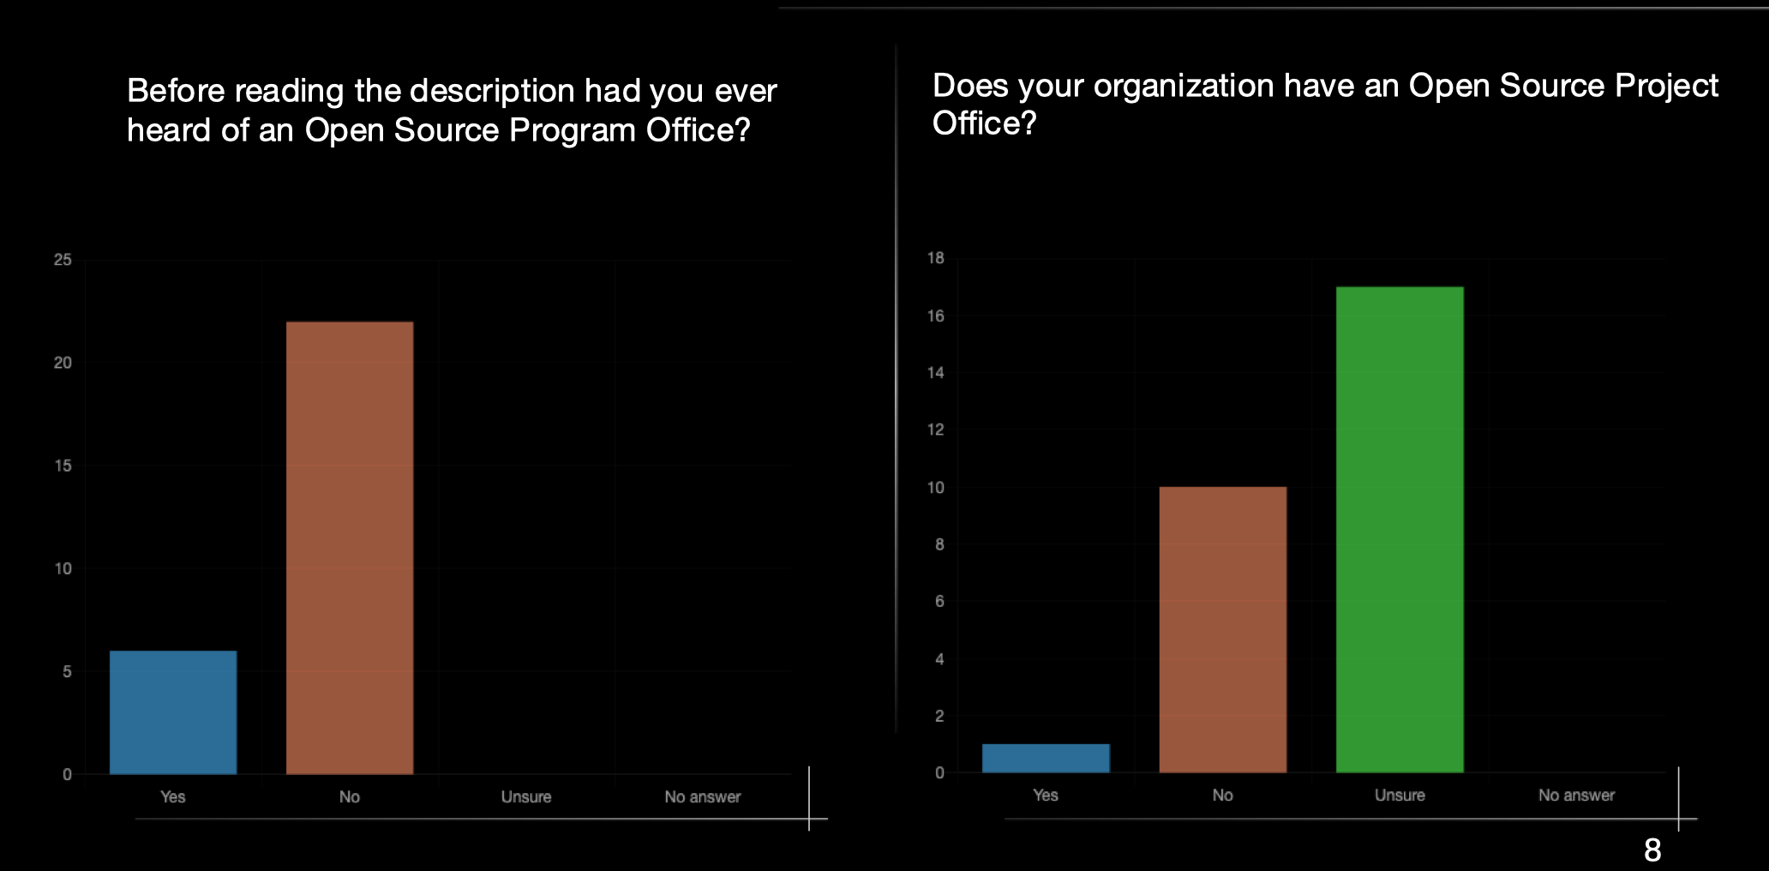

I next decided to evaluate the baseline of the OSS experience of participants – using, creating, licensing, contributing and distributing. I found that all participants had experience using OSS, and for the remainder of the categories, I found that the majority of participants had some experience.
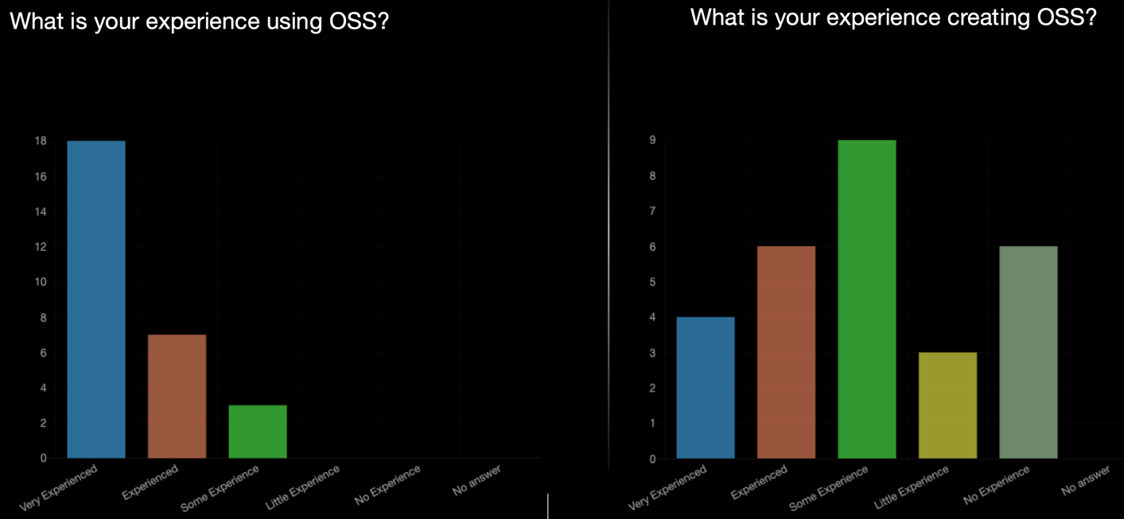

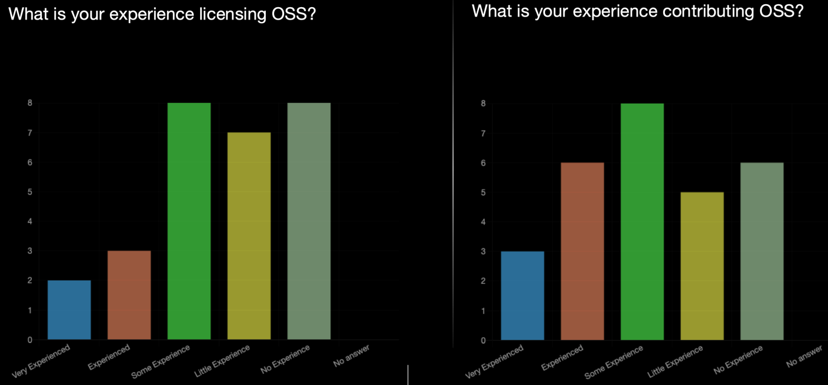

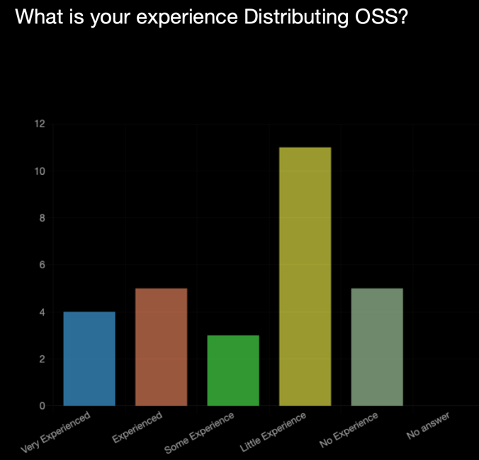

The following 5 question set was created to evaluate organizational transparency, standards, and education. I decided to go with a Likert scale to give participants more flexibility in responses, 1 needs improvement, 3 average, and 5 great.
- OSS personal guidance – Do you know who to talk to at your organization?
- OSS defined process, policy, and best practices – Do you know how the organization wants your OSS project to look?
- OSS Marketing – You know that when you open source a project users will know how to find it?
- OSS Usability – You know that when you open source projects, users can leverage them.
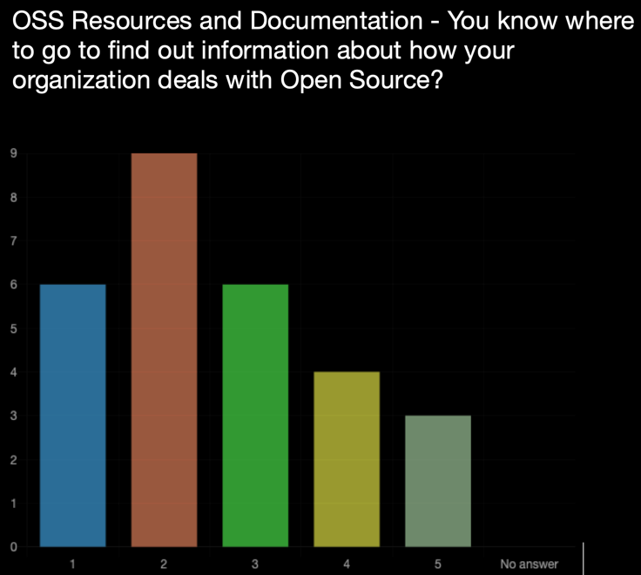
The results were fairly distributed across the scale, but when the Arithmetic mean was calculated all questions fell slightly below Average.

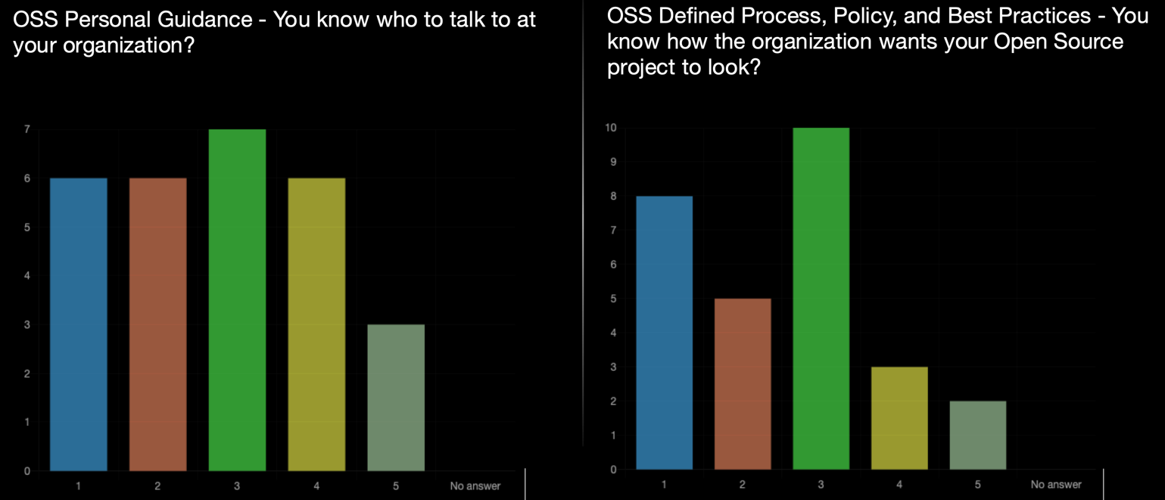

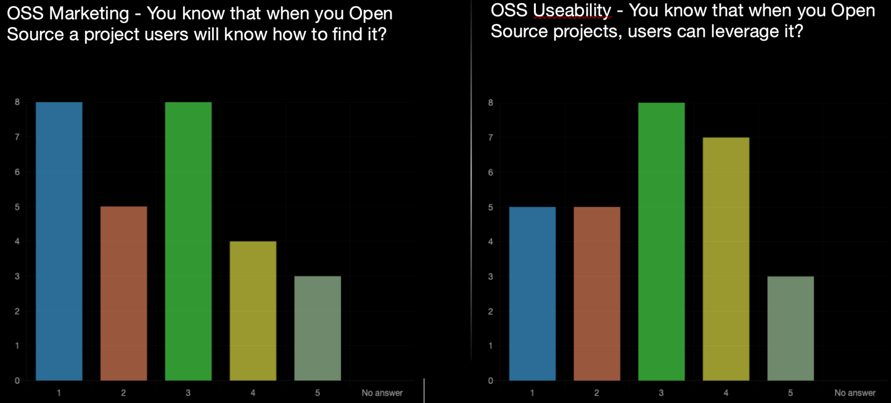

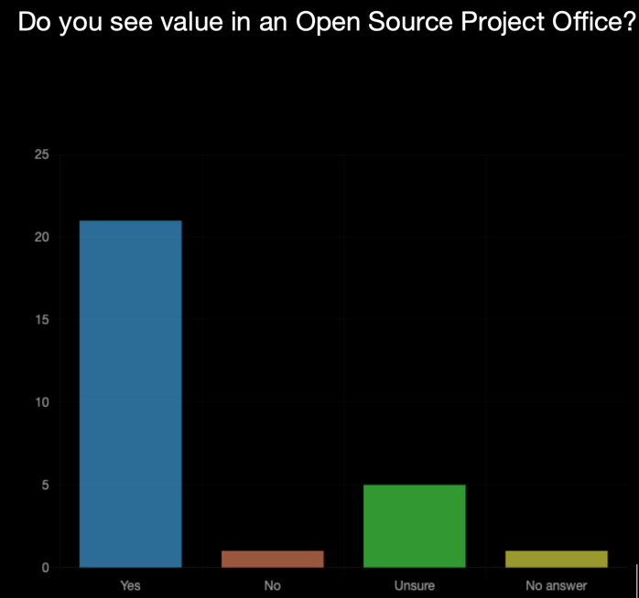
The thought the next set of questions should focus on whether at this point in the survey participants felt like they would value an OSPO and the response as can be expected was overwhelming yes.

What we learned about FFRDC employees for the survey at this point:
- They have decent experience with consuming and creating OSS.
- They somewhat understand licensing
- They do not know how the organization wants OSS releases or marketed.
- They don't always know where to get the OSS information they need.
- After learning what an OSPO is they highly support the idea.
- They appear qualified to evaluate their org.
- Based on their initial responses I would make the assumption they believe their org OSS practices are possibly immature.

The final part of the survey was to access the OSS maturity of the adoption model, taken directly from Wipro. Participants had the option not to select an answer if they did not feel qualified.

- Ad Hoc – No governance nor controls
- Aware – The organization is aware of OSS usage, security, risk, and legal.
- Managed – The organization has some sort of OSS policy in place
- Engaged – The organization contributes more actively to the OSS community and is forming an OSS strategy.
- Leading – The organization has an OSS strategy, contributes to multiple projects, and begins corporate OSS alignment.
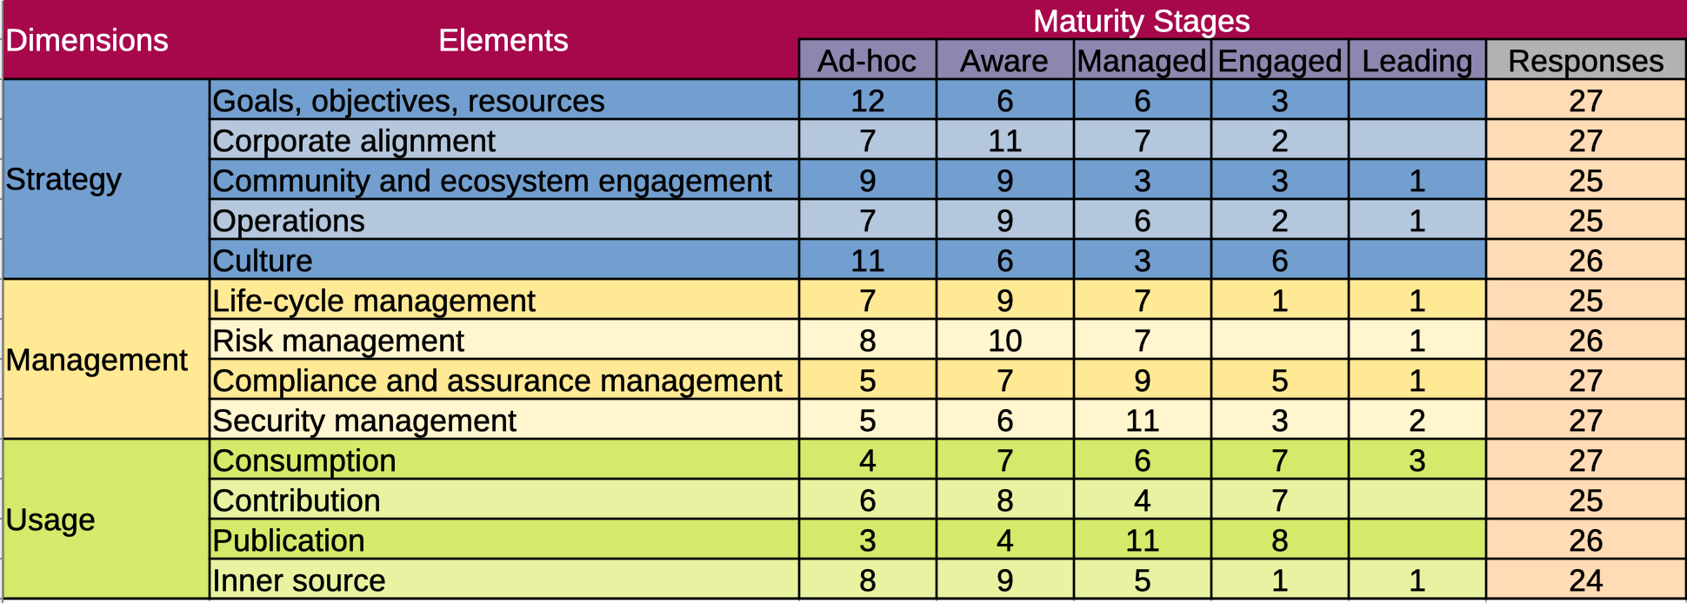

As we look at the bar graph we can see that the OSS strategy leans immature, Management leans mature, and enterprise OSS practices are firmly mature. The results are expected based on the prior question set. While evaluating the survey results I again felt my bias surfacing. I felt like I knew what responses would come from an IT professional and which would come from a researcher. I decided to hold interviews with anonymous OSS stakeholders who work, or have worked within FFRDCs.

Stakeholder Interviews:
Interviews on average last 1 hour, I loosely used the TODO Measuring your open source program's success to frame the discussion as well as my knowledge of the survey results. I wanted the conversation to happen organically. I wanted the interview participants to feel comfortable and willing to share fireside chats. The interview was not meant to be a study with results, merely a way for me to better understand the survey results. Below you will find my notes.

Information Technology Professional: My overall impression is a cynical thought process toward OSS. Many speculative answers without providing evidence to back up the response. I got the impression that if the organization had larger staffing in IT that they believed they could do a better job growing OSS maturity.
- Believes that their org may not trust that OSS is as secure as COTTS/GOTTS, but has never been officially told that. No known official policies against the use of OSS at their org but believes InfoSec and IT may discourage the use of OSS without valid justification.
- Believes some of their organizational users may work around IT policy to install OSS software becomes user manage policy.
- No real QA process for OSS release.
- Believes their organization could benefit from an OSPO.

Software Engineer: My overall impression is that they felt OSS was important to their personal development and career growth but not valued as much as they would expect from their organization. When continuing questioning past initial organizational OSS frustration, more candid responses revealed a desire for their contributions to be evaluated the same way a written publication would be. The engineer was more focused on marketing OSS, they created software and wanted people to use it.
- Licensing challenges, it is up to me to have a license reviewed. In my org, a second review happens after the software is created which can cause changes.
- Doesn't know if new features require additional review by their org.
- Doesn't feel supported in creating OSS in their org.
- Believes that If you open source software you have to maintain it. As a programmer I just want people to use my stuff. The community is important, and the point of OSS.
- Analytics from repos help drive personal motivation and satisfaction.
- Doesn't work on outside OSS projects anymore and doesn't think it would count towards career advancement in their org.

Researcher: The researcher was the first interviewee to genuinely empathize with their organization. For the most part, they felt like their organization did an average job with dealing with OSS, but that does not mean they didn't think there was room for organizational improvement. The researcher seemed to understand OSS licensing better which gave them a better understanding of why some organizational policies were in place but did not necessarily know what organizational support was available. Ultimately though that the governance an FFRDC must follow made an OSPO irrelevant.
- Follows ABC – Adopt, Buy, Create
- Checks licensing and don't want to fall in love with code they ultimately they cant use.
- Hates software with licenses designed to extract additional revenue that does not provide additionally needed features.
- Runs licenses by ethics and compliance/legal before integrating OSS.
- Does not know the internal process for release approval of OSS in their org.
- Does not know if resources are available for OSS release quality assurance in their org.
- Unsure if their org wants them to be an active member in the OSS community.
- Unsure if an OSPO could be successful in their org.

Review and Approval: First off they wanted to make clear this is a candid conversation, not to be considered legal advice and that anyone should check with their organization for OSS review and approval policies. The first thing I want to make clear as an author is that this individual couldn't have been nicer or more generous with their time, I conducted multiple interviews for clarification and they answered all my questions to the best of their ability. Ultimately they protect the organization and the employee. Many interviewees expressed frustration with the process of dealing with review and approval, after my interviews I believe this to be unfounded. What it reveals is a lack of process transparency, I believe better documentation and outreach would help. Just like the DoD FAQ, the process of releasing any OSS starts with sponsor approval. Collaborating on OSS projects outside of sponsored work could be considered a conflict of interest and you should always check with your organization's compliance department to confirm it's okay.
- !!!!NOT TO BE CONSIDERED LEGAL ADVICE
- Starts with reviewing your organization their terms and agreements with its sponsors to ensure you are not violating any information disclosure causes.
- When you use other software with varying licenses it is good practice to have your legal department review the terms of licenses to make sure you can comply with them.
- After your organization approves it, it may have to go to your organizations funding sponsor to clear for open release.
- After it is approved by all parties you should be good to publish
- Any updates to the project may require additional review. Check with your organization.
- Collaboration activity can be viewed as a conflict of interest, check with your org.
- Super Nice BTW.

OSS Expert: This individual has decades of experience in OSS and actively contributes to the OSPO community. I chose this individual to be my last interview simply so I could be prepared. What I quickly discovered is that I could have spent a year prepping and would have still not been able to keep up with the discussion. In one word, humbled. Over nearly 3 hours without prompting, the OSS expert confirmed nearly everything mentioned in other interviews but also gave the counterpoint to why FFRDCs operated in that manner. Easily the most grounded interview. They liked the idea of OSPOs but did not necessarily believe every organization needs one, especially if they can access an OSPO office through OSPO++. The OSS expert did not believe in assigning a maturity level to an organization, as many assessments could be flawed and without definitive proof the value assigned didn't matter. I tend to agree with this assessment.
- A, B, and C as well as security concerns are your due diligence, long-term project, and willingness to maintain it.
- Believes OPSOs are popular at most small and large companies but does not see a specific need for an OSPO at all organizations.
- Likes the ideas of OPSO++ traditional OSPO which creates a substrate for boarding addition groups
- Just because you create a great application doesn't mean it will inspire collaboration
- Believes FFRDCS prefers to operate in Silos
- Believes Linux best practices badges don't necessarily match the scorecard
- Believes without evidence the maturity level is pointless
- Believes that to incentive OSS contributions, they must be notable contributions that can be relevant to a DoD mission priority.
- Review and Approval are important. If something goes wrong jobs could be at stake, CYA

Evaluation:
It would be easy to say I only needed to interview the expert since they told me essentially covered the content that all other interviews mentioned. I feel that would be an incorrect assessment. Doing that would have limited my community understanding. FFRDCs are OSS processes that are easily mature given their sponsorship governance but slightly immature when compared to traditional enterprises. The OSS community is what you make of it, I found the FFRDC OSS community to be extremely passionate and resolute in their principles. A massive amount of personal time from multiple individuals was given freely to this project, that's the start of a mature community.

- FFRDC employees want to actively participate within the OSS community.
- The DoD openly encourages OSS.
- FFRDCs mission aligns with transition software by open sourcing.
- The way an FFRDC is structured makes it difficult to participate in the OSS community the same way nonprofits and for-profit, companies can.
- A lack of OSS process transparency causes confusion and unfair immaturity labeling.
- I believe FFRDC OSS policies are mature but that does not mean there is no room for improvement.
- Professor Wasserman said I most likely couldn't get everything I wanted to be done in a six-week class and he was right.
- If I had to assign an unofficial score I would set FFRDCs slightly below a maturity level 3.

Github:
A Github repository containing project data has been created so that others may advance this work.
https://github.com/daross-ai/OSS-FFRDC-Maturity

Open Source Software: During the entirety of this report I only used open source software. Learning the different forms of software while time-consuming was a fantastic exercise as in the past my experience with most OSS was limited. I firmly believe most individuals could benefit from saving money on software purchases by using OSS alternatives and paying the community back through contributions.
- Firefox – Used for web browsing
- GIMP – Photo manipulation
- OBS – Screen recording
- Limesurvey – Surveying
- LibreOffice – Word processor, Presentation Creation, Spreadsheet
- Craiyon "Dalle-Mini" – Generate images from text prompt using trained models with machine learning to create unique creations.
- Creative Commons: Access to CC Licensed resources, namely free images when following terms of use.

Starting OSS Check list Questions
You have reviewed compliance guidance with your organization prior to starting development
You have created your Open Source Project Team (Even if the is a team of 1)
You have created an Open Source Release Roadmap with your team
You have dedicated Adequate resources to fulfill the roadmap vision and lifecycle
You have started working with your FFRDC and sponsor for release approval
You have reviewed licensing options with code you will write with your legal team
You have reviewed licensing options with code you will adopt with your legal team
Code is written
Code contains proper documentation
Code has passed testing parameters
Code has been checked for sensitive data
Code dependencies have been documented
Code and licenses have been review with organization, legal, and sponsor
You have sponsor approval to release
You have organization approval to release
You have contacted a technical writer to create readme and wiki documentation
You have contacted distribution channel owner to create a repo
You commit your code
You work with your companies marketing and communication to create a marketing and collaboration plan
You have adequate resources maintaining the repo and participating in the community
You get approval form your organization prior to committing new code base and features

Future Work:

- The survey will stay active and the project data will be update quarterly.
- I will approach other FFRDCs to create a collaboration group to standardize documentation and best practices across the FFRDCs.
- Work with my own organization to evangelize the adoption and creation of OSS.
- Work with my organization OSPO to simplify FFRDC open source standards.
- I will work with my organization for and approval to create a white paper publication.

Project Timeline:
Lit Review Week 1 &2
Survey Creation Week 2 & 3
Survey Ran Week 3 – 6
Interviews Week 4 – 5
Github Week 5 & 6
Presentation Week 5 & 6
Report Week 5 & 6

References: This project is given in line as hyperlinks. URLs are ordered when they appear in the report
- https://linuxfoundation.org/tools/the-evolution-of-the-open-source-program-office-ospo/
- https://ospoplusplus.com/
- https://www.cmu.edu/news/stories/archives/2022/july/sloan-foundation-funds-new-office-to-support-open-source-activities.html
- https://www.wipro.com/innovation/what-open-source-maturity-model-can-do-for-your-enterprise/
- https://todogroup.org/guides/using-open-source/
- https://todogroup.org/guides/participating/
- https://todogroup.org/guides/recruiting-developers/
- https://todogroup.org/guides/starting/
- https://todogroup.org/guides/shutting-down/
- https://todogroup.org/guides/building-leadership/
- https://todogroup.org/guides/marketing-open-source-projects/
- https://dodcio.defense.gov/open-source-software-faq/
- https://www.congress.gov/115/plaws/publ232/PLAW-115publ232.pdf
- https://www.csiac.org/journal-article/open-source-software-is-commercial/
- http://creativecommons.org/
- http://www.wikipedia.org/
- https://daross.limesurvey.net/593425?lang=en
- https://linuxfoundation.org/tools/the-evolution-of-the-open-source-program-office-ospo/
- https://wiprotechblogs.medium.com/assessing-the-maturity-of-open-source-adoption-in-an-enterprise-d2ac371be993
- https://todogroup.org/guides/measuring/
- https://www.mozilla.org/en-US/firefox/products/
- https://www.gimp.org/
- https://obsproject.com/
- https://obsproject.com/
- https://www.libreoffice.org/
- https://www.craiyon.com/
- https://www.craiyon.com/
- https://creativecommons.org/

